Steps to install HDP using ambari:

1. Select the cluster install wizard.
2. Give the name to the cluster and select next.

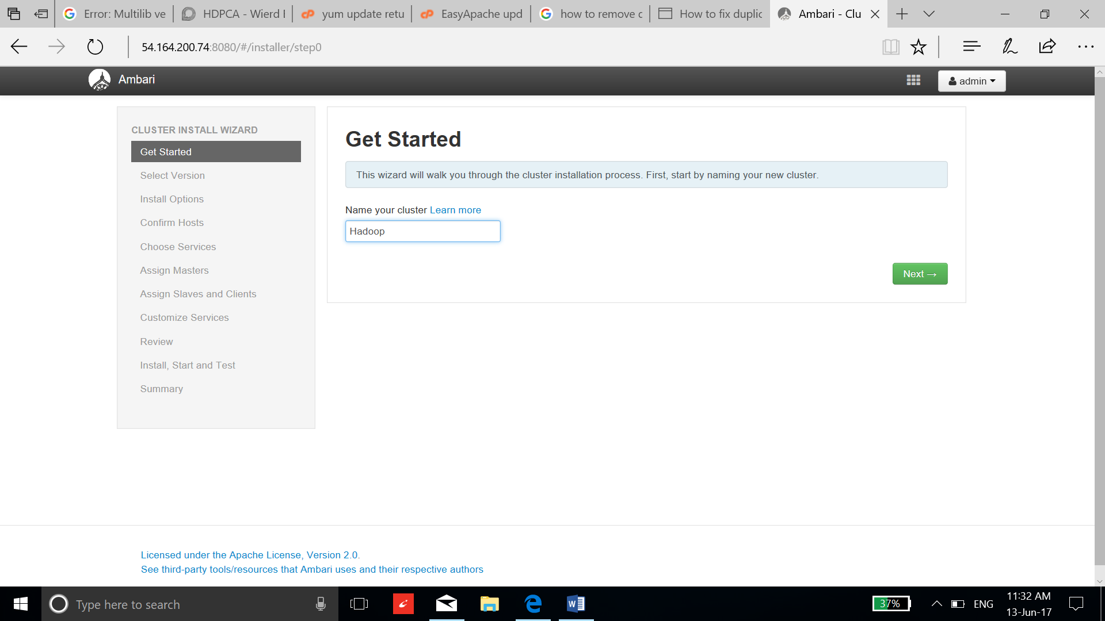

1. Select the version to install and keep one repository which matches your AMI.

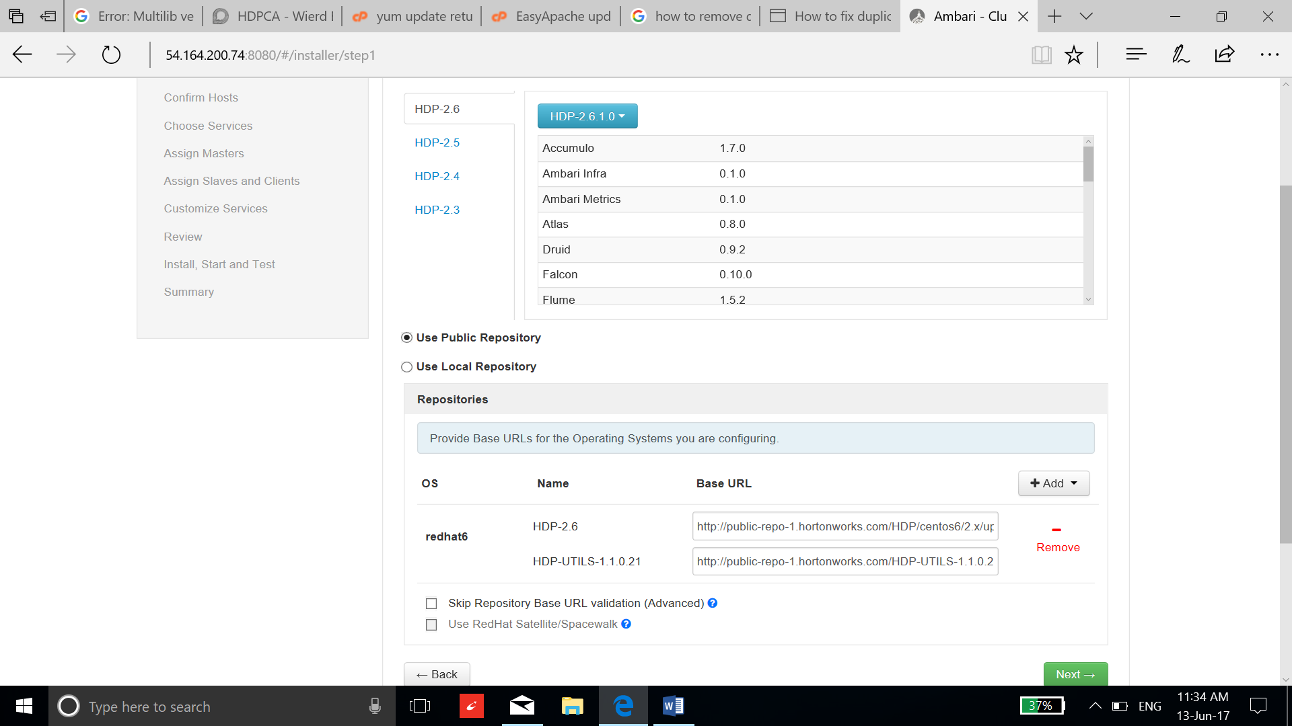

1. Enter the private DNS name of all the nodes and select the manual installation option.

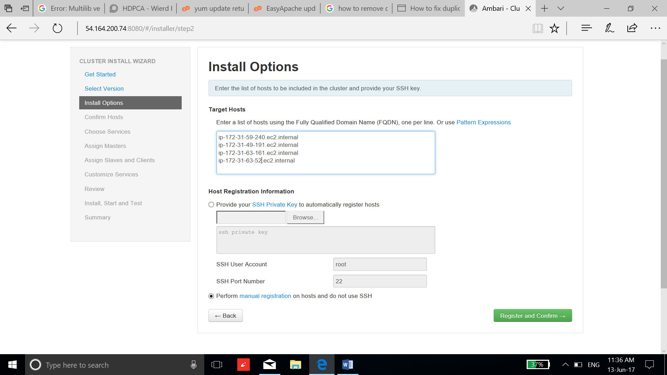

1. Resolve the problems if any and select next.

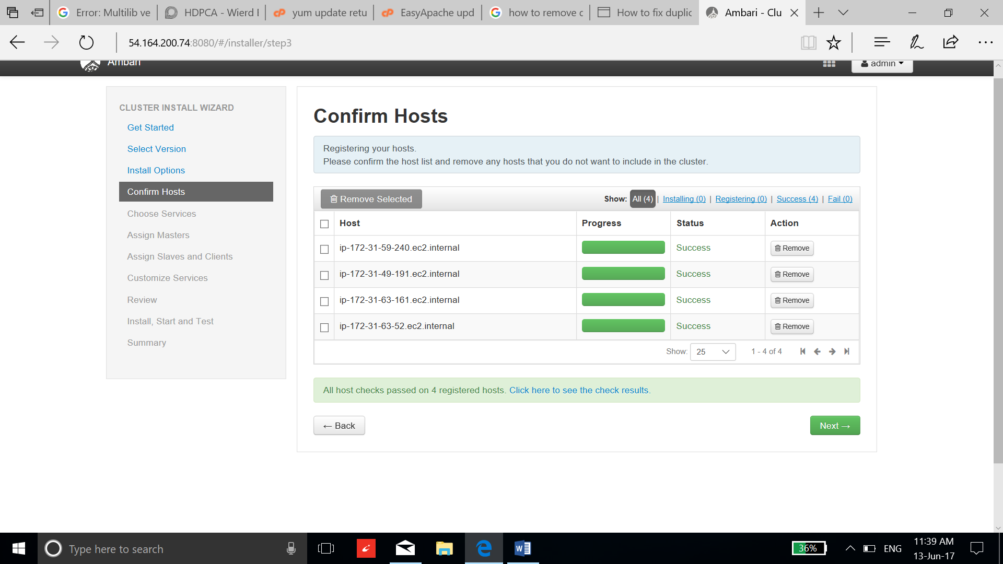

1. Select the services to be installed and select next.

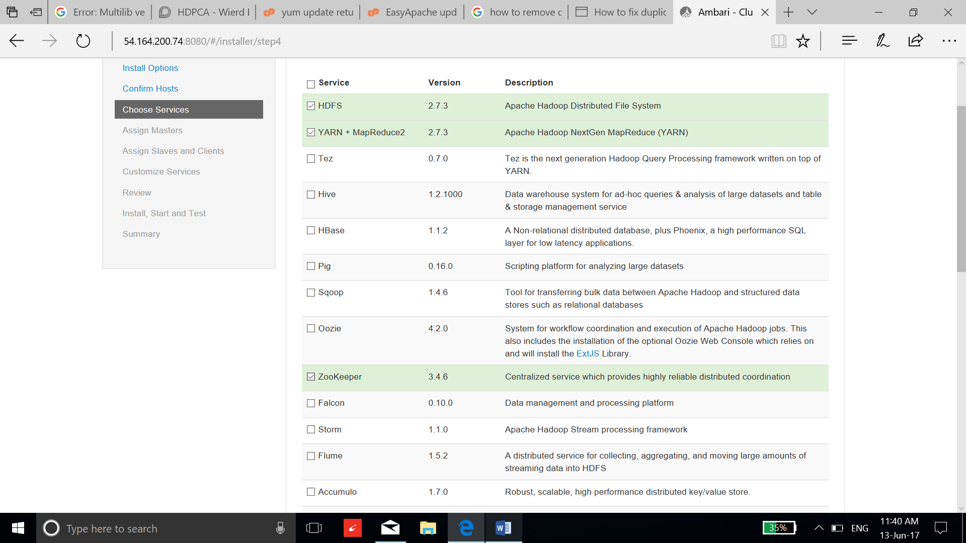

1. Assign the configuration according to the needs and select next. I am using the default configuration for this purpose.

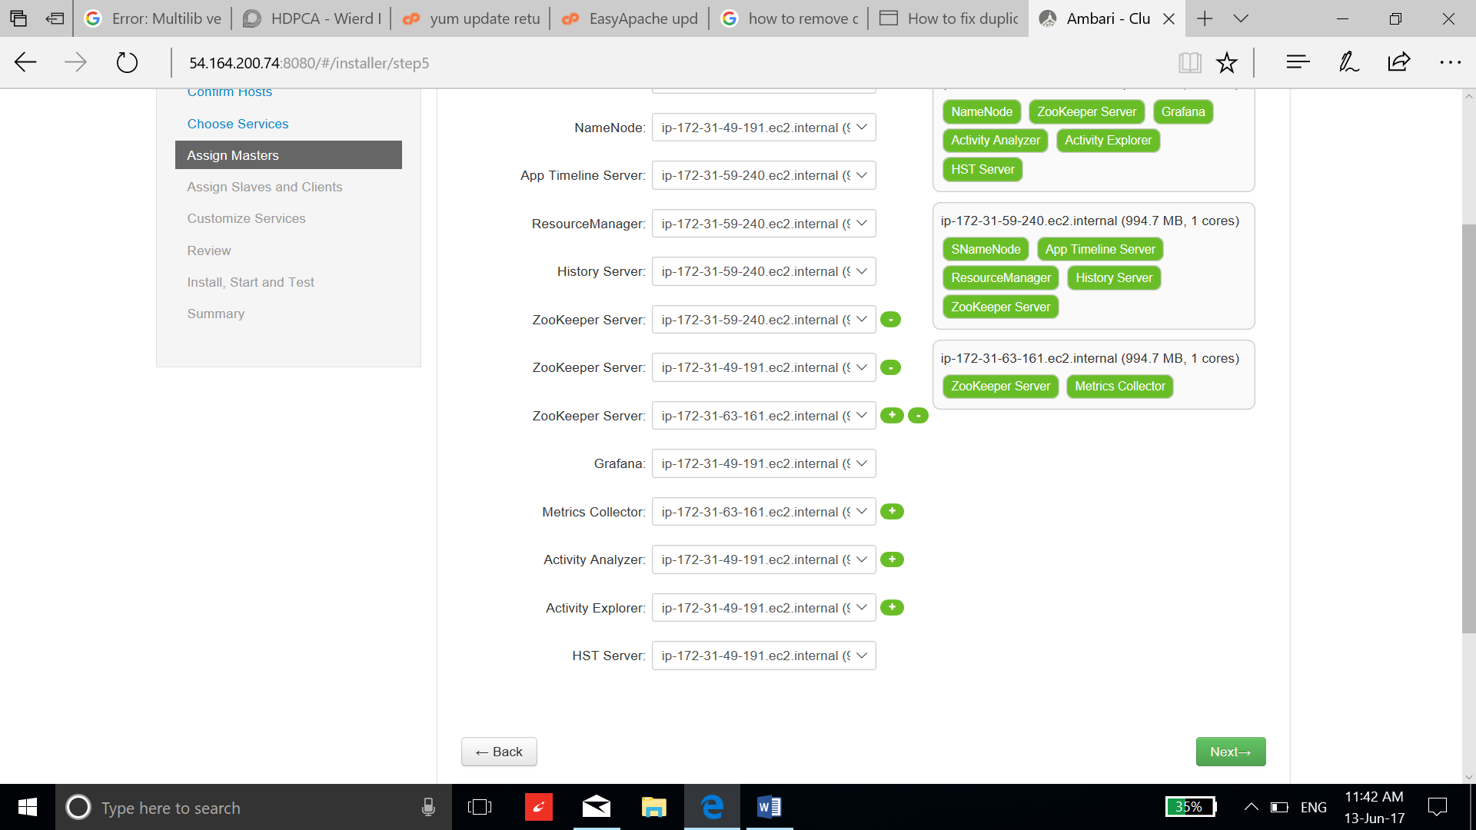

1. Select all the clients, datanode and namenode and go to the next page.

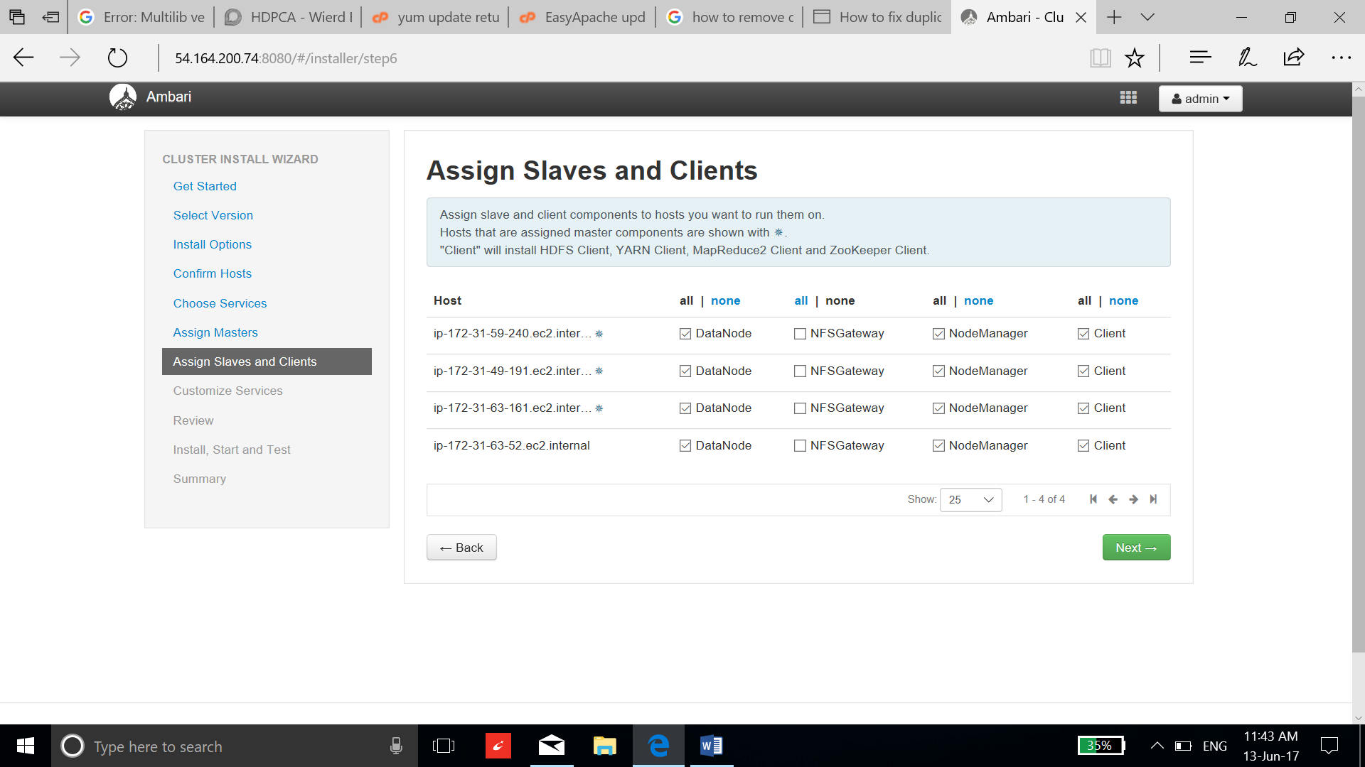

1. Select the required passwords and select next.

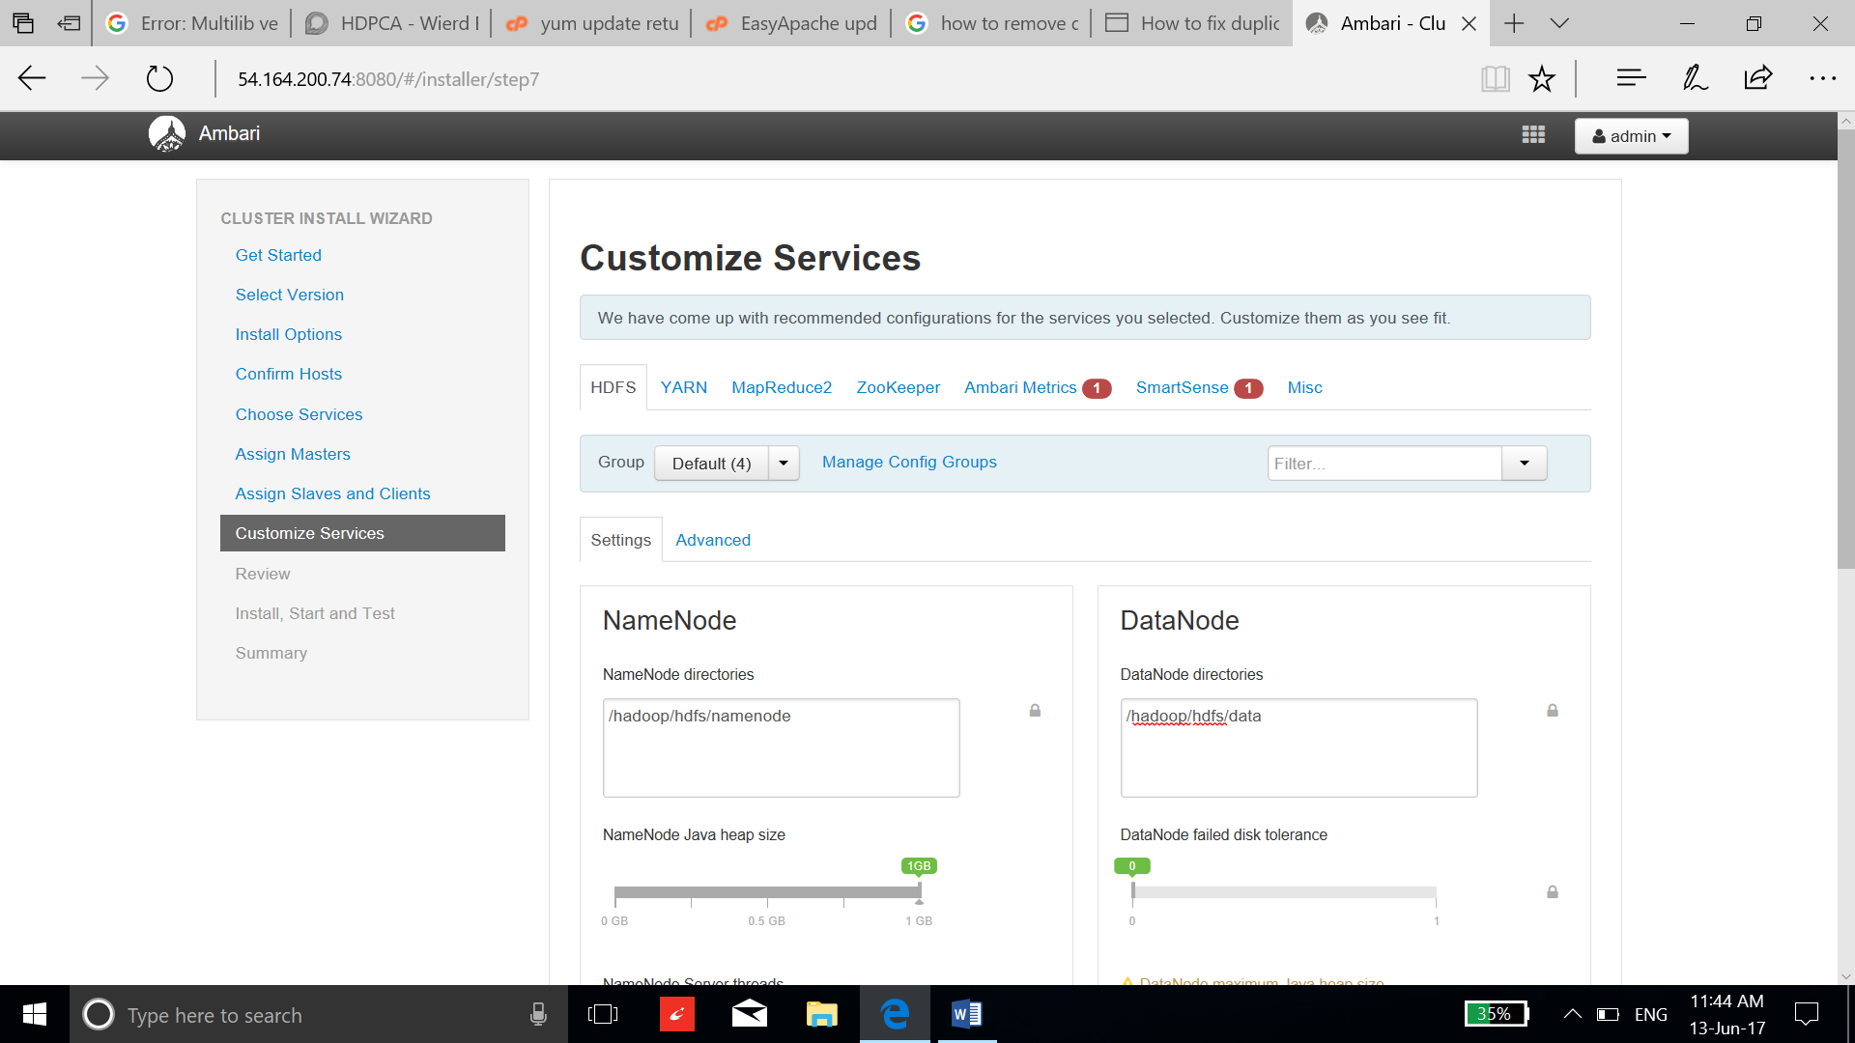

1. Review the repositories and select deploy.

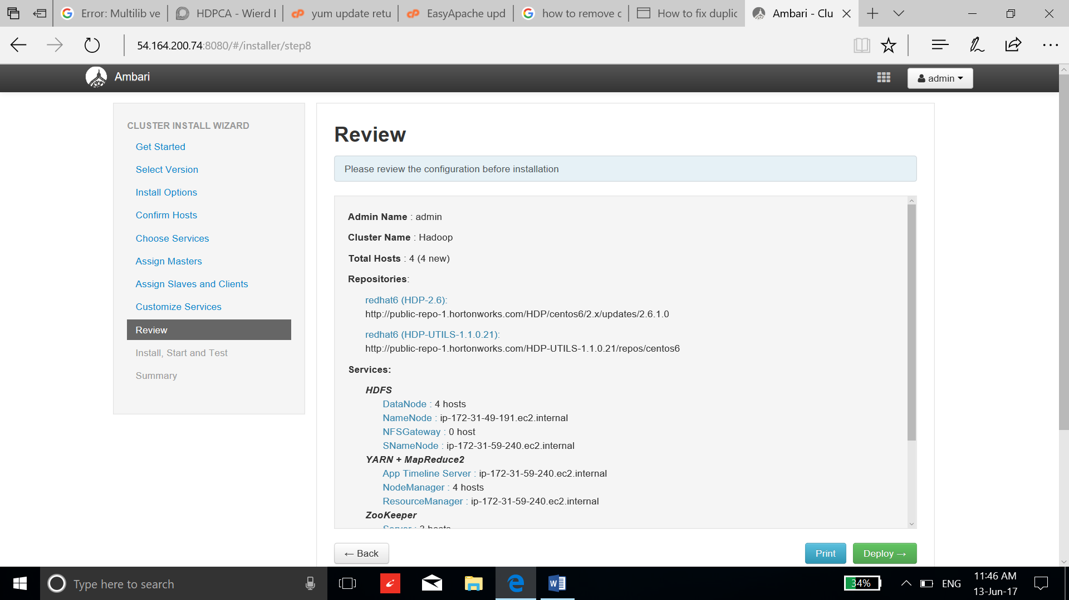

1. After the successful installation and start-up you can select next.

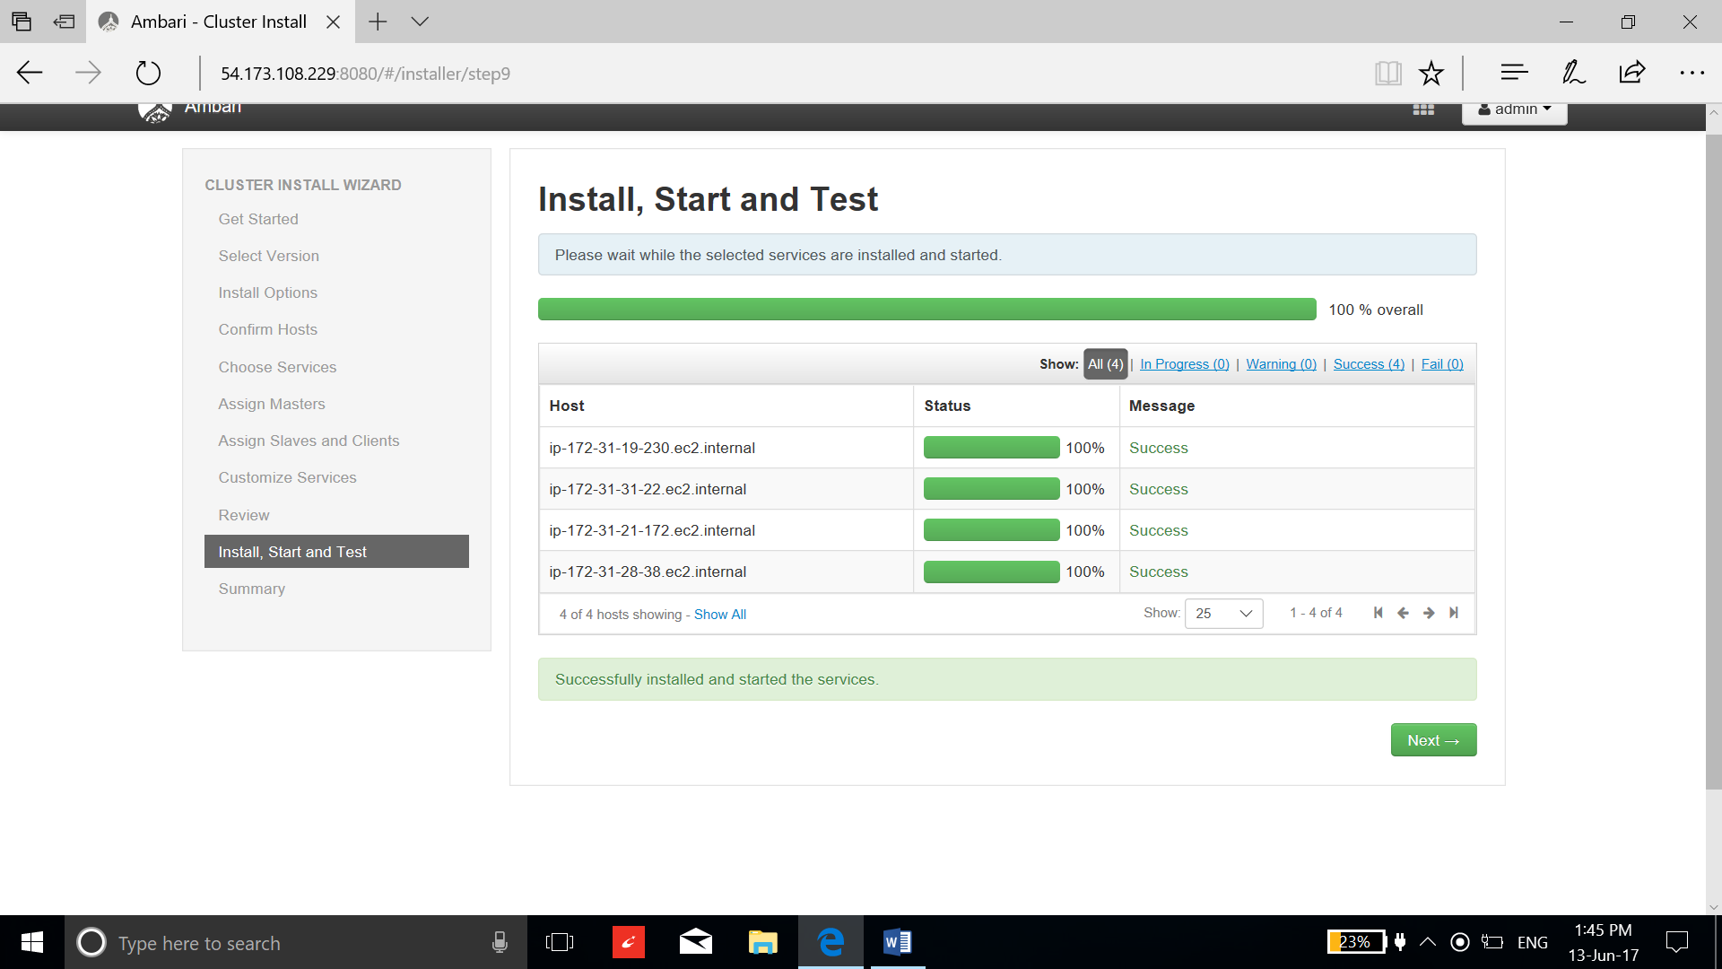

1. Select complete and start using the services.

